Project Design Phase-I
Solution Architecture

Date | 31 January 2026
Team ID
Project Name | Global Electric Vehicle Market Performance Analysis  (Medi-Caps University)
Maximum Marks | 4 Marks

Solution Architecture:
Solution architecture is a complex process – with many sub-processes – that bridges the gap between business problems and technology solutions. Its goals are to:
- Find the best tech solution to solve existing business problems.
- Describe the structure, characteristics, behavior, and other aspects of the software to project stakeholders.
- Define features, development phases, and solution requirements.
- Provide specifications according to which the solution is defined, managed, and delivered.

Sample Solution Architecture Diagram:
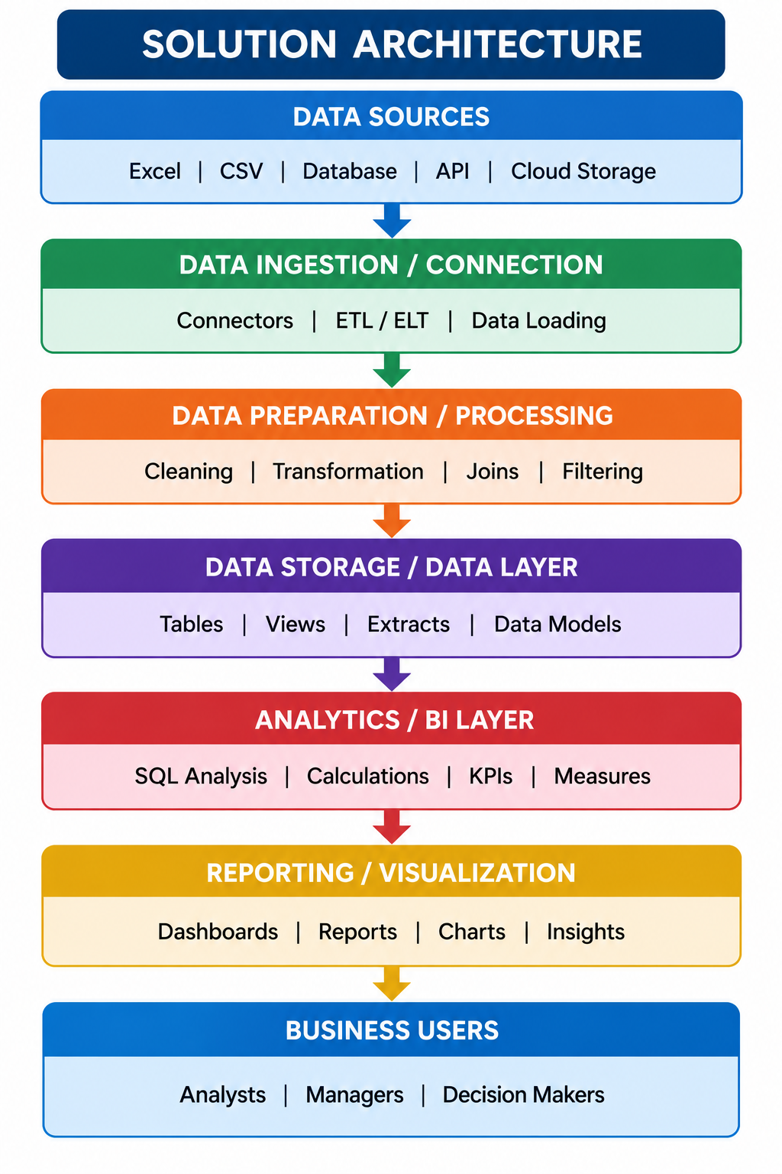

Component Description Table
Component Name | Description / Role in Architecture | Technology Used
1. Data Ingestion Layer | Handles bulk ingestion and staging of 200,000 raw vehicle telemetry records from Excel/CSV files into Snowflake staging environments. | Snowflake Internal Named Stage (@STG_EV_DATA), COPY INTO SQL command, OpenPyXL
2. Data Storage & Staging Layer | Maintains raw, immutable transactional tables and tracks loading metadata with schema validation. | Snowflake RAW_SCHEMA, RAW_EV_MARKET_DATA table
3. Transformation & Modeling Layer | Executes SQL cleansing (null imputation, duplicate elimination) and structures data into a dimensional Star Schema with Fact and Dimension tables. | Snowflake ANALYTICS_SCHEMA, DIM_MANUFACTURER, DIM_CATEGORY, DIM_BATTERY_TECH, FACT_EV_SALES

End-to-End Solution Architecture Diagram
+---------------------------------------------------------------------------------------------------------+
| PRESENTATION & CONSUMPTION LAYER |
| +---------------------------------------------+ +-----------------------------------------------+ |
| | Flask Web Portal (app.py) | | Tableau Public Cloud Visual Embed | |
| | - /dashboard (Tableau Live Embed) | | - Executive KPI Dashboard (6 Core Cards) | |
| | - /story (10-Scene Narrative Embed) | | - 9 Interactive Sheets (Bar, Map, Line, Mix) | |
| | - /insights (Analytical Commentary) | | - 10-Scene Strategic Journey Narrative | |
| | - /api/stats (RESTful Telemetry JSON API) | | - Dynamic Filters: Region, Mfr, Category | |
| +---------------------------------------------+ +-----------------------------------------------+ |
+---------------------------------------------------------------------------------------------------------+
▲
| Secure HTTPS / Tableau JavaScript API
+---------------------------------------------------------------------------------------------------------+
| ANALYTICS & BUSINESS INTELLIGENCE LAYER |
| +-------------------------------------------------------------------------------------------------+ |
| | Tableau Hyper In-Memory Data Extract (.hyper) | |
| | - Calculated Measures: Unit Sales Sum, Avg Range (km), Weighted Customer Rating, Mfr Count | |
| +-------------------------------------------------------------------------------------------------+ |
+---------------------------------------------------------------------------------------------------------+
▲
| High-Speed Direct Warehouse Connection / ODBC
+---------------------------------------------------------------------------------------------------------+
| SNOWFLAKE DATA WAREHOUSE LAYER |
| +---------------------------------------------+ +-----------------------------------------------+ |
| | ANALYTICS_SCHEMA (Star Schema) | | RAW_SCHEMA & STAGING AREA | |
| | - FACT_EV_SALES_PERFORMANCE | | - STG_EV_DATA (Snowflake Internal Stage) | |
| | - DIM_MANUFACTURER (200 OEMs, HQ Country) | | - RAW_EV_MARKET_DATA (200k Rows, 37 Cols) | |
| | - DIM_VEHICLE_CATEGORY (SUV, Hatch, etc.) | | - Automated Null Imputation & Deduplication | |
| | - DIM_BATTERY_TECH (NMC, LFP, Degr 5yr) | | - Audit Log & Data Quality Validation Engine | |
| +---------------------------------------------+ +-----------------------------------------------+ |
| COMPUTE_WH: Virtual Warehouse (X-Small, Elastic Auto-Suspend 60s) |
+---------------------------------------------------------------------------------------------------------+
▲
| Bulk Data Load (COPY INTO)
+---------------------------------------------------------------------------------------------------------+
| DATA SOURCE LAYER |
| +-------------------------------------------------------------------------------------------------+ |
| | ev_market_train.xlsx (50.3 MB Dataset | 200,000 Records | 37 Specifications & Telemetry Fields) | |
| +-------------------------------------------------------------------------------------------------+ |
+---------------------------------------------------------------------------------------------------------+

